Energy stores and transfers
Basic
- What does the principle of conservation of energy say?
- Name four different energy stores?
- What is unwanted energy called?
- What are the two most common forms of unwanted energy?
- What store of energy does a chocolate bar have?
- What store of energy does a moving motorbike have?
- What two stores of energy does a moving aeroplane that’s high in the sky have?
- What store of energy does a helicopter hovering (not moving) have?
- What store of energy does a stretched elastic band have?
- What store of energy does petrol have?
Medium
- What are the input and output energies for each of the following (including any wasted energies):
- A light bulb
- A cyclist travelling along a road.
- A calculator with a solar panel.
- A bow and arrow being fired.
- An aeroplane taking off.
- Turning on a torch.
- Lighting a candle.
- Rubbing your hands to keep them warm.
- Bouncing on a trampoline.
Hard
- Roger Federer serves a tennis ball directly into the air. List all of the energy transfers that occur. Include the tennis ball returning to the ground, and then bouncing back up again.
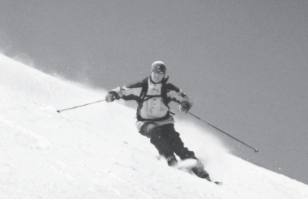
- Andrew skis down a hill. Andrew starts from the top of the hill and his speed increases as he goes downhill.
He controls his speed and direction by using his skis.
He brings himself to a stop at the bottom of the hill.
Describe the energy changes that happen between starting and stopping. [3 marks]

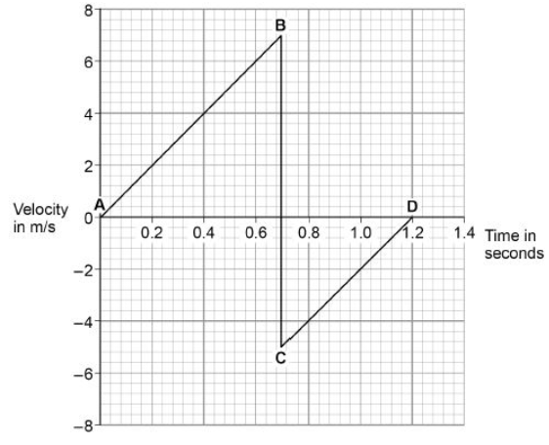
14. A child drops a ball.

The ball hits the ground and bounces.

The graph to the left shows the velocity-time graph for the ball from when the ball is dropped until when the ball reaches the top of its first bounce.

Air resistance has been ignored.

When the ball hits the ground, energy is transferred from the ball to the Earth.

Explain how the data in the graph above shows this energy transfer.

